- The updated source code (or a diff/patch). \
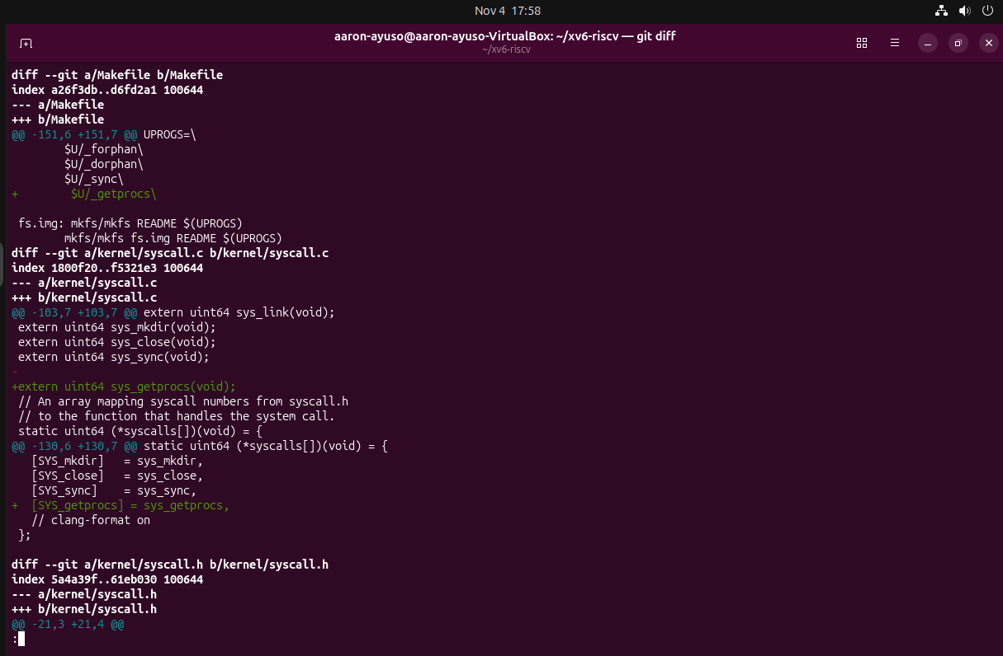
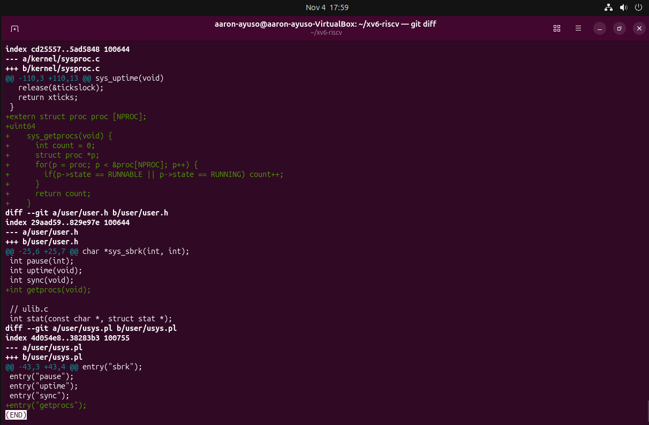
- The user test program getprocs.c.
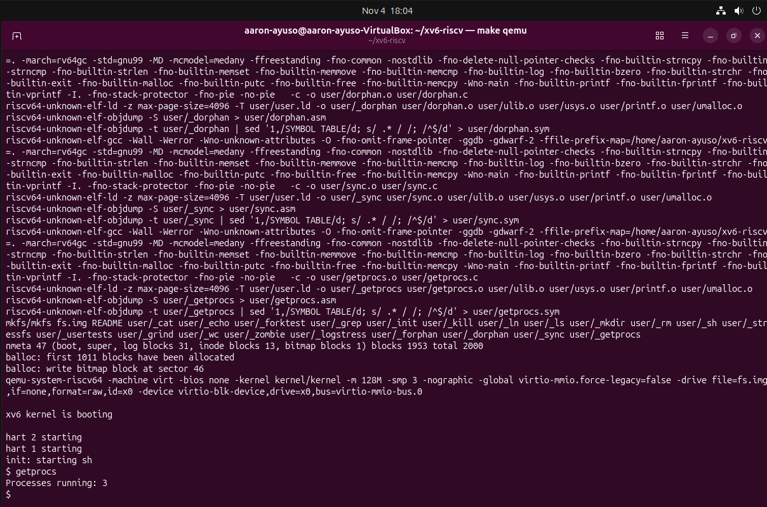

Extra Credit (optional, +2 pts)
Modify getprocs() so it only counts processes in the RUNNABLE or RUNNING states.
Modified getprocs()
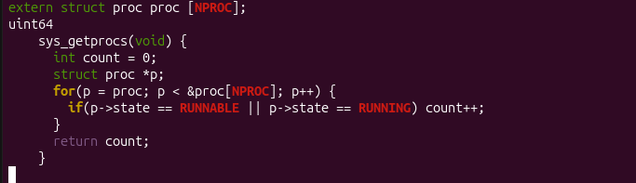

Output with modified getprocs()


